Gateway Sertoma
News Release

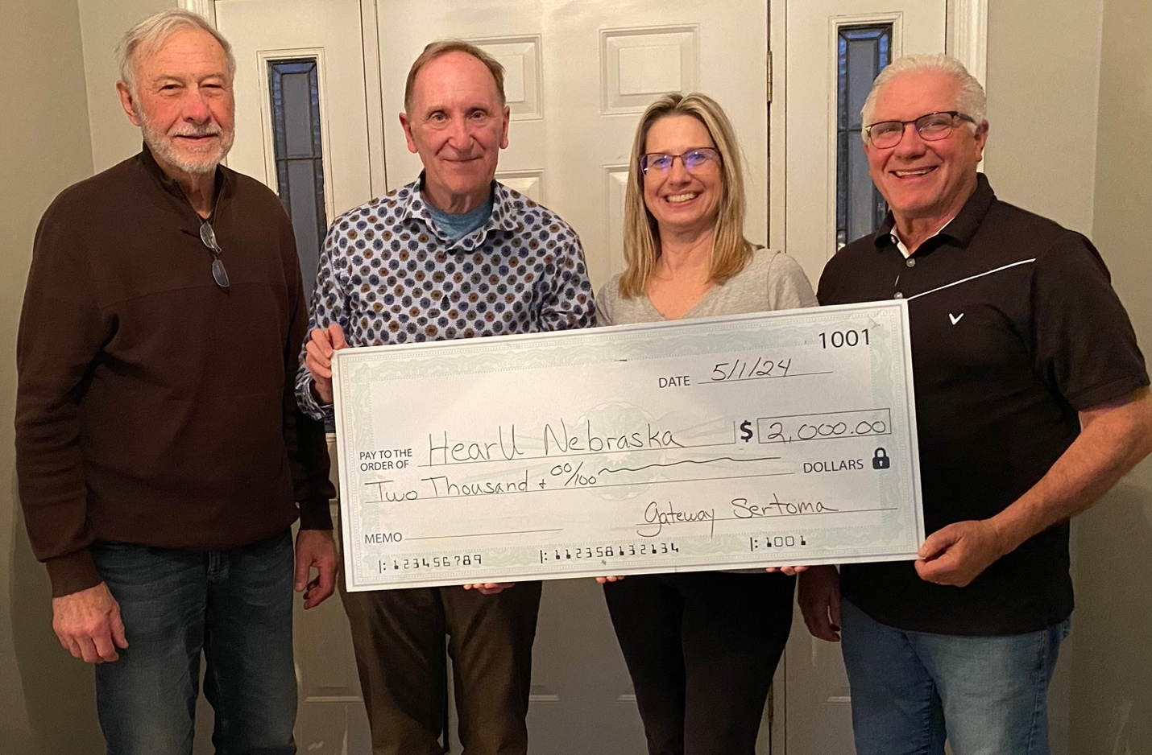
Left to right: Harold Klein, Kevin Miller, Stacie Ray, and Jim Krysl

Gateway Sertoma Supports HearU Nebraska
May 2, 2024

The Gateway Sertoma Club presented HearU Nebraska with a check for $2,000. HearU Nebraska provides hearing aids to children 0-18 years of age along with hearing aid batteries, kits for maintaining hearing aids, and costs associated with maintenance, replacement, and fitting of these devices. Since 2008 it has provided hundreds of hearing aids to hard of hearing children throughout Nebraska. Sertoma Club Grants support community charitable programs and organizations, and helped fund this donation. Gateway Sertoma members Harold Klein, Kevin Miller, and Jim Krysl presented the check to Dr. Stacie Ray, representing the University of Nebraska-Lincoln Barkley Memorial Center and HearU Nebraska.

